Fundamentals of Data Science
Assessment Tool 3
Question 4 – Banking Loan Approval Dataset
Objective
The objective of this analysis is to perform Exploratory Data Analysis (EDA) on a banking loan approval dataset to understand the relationship between income, credit score, loan amount, employment type, and loan approval status. The analysis aims to identify the key factors that influence loan approval decisions, discover patterns in customer financial profiles, and provide insights that can help banks improve their loan evaluation process. The findings can support better risk assessment, reduce loan defaults, and enable more informed and fair lending decisions.

# ==========================================================
# Import Required Libraries
# ==========================================================
import pandas as pd import numpy as np import matplotlib.pyplot as plt import seaborn as sns %matplotlib inline
plt.style.use("ggplot") sns.set_theme(style="whitegrid") print("Libraries imported successfully.")
In [2]:
Libraries imported successfully.
<h2 id="Dataset-Description">Dataset Description</h2><h3 id="Problem-
Statement">Problem Statement</h3><p>A bank wants to analyze loan approval decisions based on income, credit score, loan amount, employment type, and approval status.</p> <h3 id="Dataset-Features">Dataset Features</h3>
Customer_ID
Income
Credit_Score
Loan_Amount
Employment_Type
Loan_Status
Target Variable
Loan_Status (Approved / Rejected)
# ==========================================================
# Create Banking Loan Dataset
# ==========================================================
bank = {
"Customer_ID":["C01","C02","C03","C04","C05","C06","C07","C08","C09","C10",
"C11","C12","C13","C14","C15","C16","C17","C18","C19","C20"],
"Income":[45000,25000,60000,22000,50000,30000,70000,28000,55000,24000,
65000,35000,48000,26000,75000,32000,52000,27000,68000,23000],
In [3]:
"Credit_Score":[720,580,750,560,710,600,780,590,730,570,
760,620,700,585,790,610,725,575,770,555],
"Loan_Amount":[200000,150000,300000,120000,250000,180000,350000,160000,270000,1
320000,200000,240000,140000,400000,190000,260000,150000,330000,1
"Employment_Type":["Salaried","Self-employed","Salaried","Unemployed","Salaried "Self-employed","Salaried","Self-employed","Salaried","Unemp "Salaried","Self-employed","Salaried","Unemployed","Salaried "Self-employed","Salaried","Self-employed","Salaried","Unemp
"Loan_Status":["Approved","Rejected","Approved","Rejected","Approved","Rejected
"Approved","Rejected","Approved","Rejected","Approved","Rejected
"Approved","Rejected","Approved","Rejected","Approved","Rejected
"Approved","Rejected"]
} df4 = pd.DataFrame(bank) df4.head()
Out[3]:

C01 | 45000 | 720 | 200000 | Salaried | Approved
C02 | 25000 | 580 | 150000 | Self-employed | Rejected
C03 | 60000 | 750 | 300000 | Salaried | Approved
C04 | 22000 | 560 | 120000 | Unemployed | Rejected
C05 | 50000 | 710 | 250000 | Salaried | Approved
In [4]: print("Shape:", df4.shape)
print("\nDataset Information") df4.info()
print("\nData Types") print(df4.dtypes) Shape: (20, 6)
Dataset Information
<class 'pandas.DataFrame'>
RangeIndex: 20 entries, 0 to 19 Data columns (total 6 columns):
# Column Non-Null Count Dtype --- ------ -------------- ---- 0 Customer_ID 20 non-null str
- Income 20 non-null int64
- Credit_Score 20 non-null int64
- Loan_Amount 20 non-null int64
- Employment_Type 20 non-null str 5 Loan_Status 20 non-null str dtypes: int64(3), str(3) memory usage: 1.1 KB
Data Types
Customer_ID str
Income int64
Credit_Score int64
Loan_Amount int64
Employment_Type str Loan_Status str dtype: object
print("Missing Values") print(df4.isnull().sum())
print("\nDuplicate Records") print(df4.duplicated().sum())
print("\nEmployment Types") print(df4["Employment_Type"].unique())
In [5]:
Missing Values
Customer_ID 0
Income 0
Credit_Score 0
Loan_Amount 0
Employment_Type 0 Loan_Status 0 dtype: int64
Duplicate Records
0
Employment Types
<StringArray>
['Salaried', 'Self-employed', 'Unemployed']
df4.describe()
Length: 3, dtype: str In [6]:
Out[6]:
20.000000 | 20.000000 | 20.000000
43000.000000 | 664.000000 | 223250.000000
17923.815383 | 85.526235 | 83733.207272
22000.000000 | 555.000000 | 120000.000000
26750.000000 | 583.750000 | 150000.000000
40000.000000 | 660.000000 | 200000.000000
56250.000000 | 735.000000 | 277500.000000
75000.000000 | 790.000000 | 400000.000000
In [7]: print("Average Income:", df4["Income"].mean()) print("Average Credit Score:", df4["Credit_Score"].mean()) print("Average Loan Amount:", df4["Loan_Amount"].mean())
print("\nLoan Status") print(df4["Loan_Status"].value_counts())
Average Income: 43000.0
Average Credit Score: 664.0
Average Loan Amount: 223250.0
Loan Status
Loan_Status
Approved 10
Rejected 10
plt.figure(figsize=(6,4)) df4["Loan_Status"].value_counts().plot(kind="bar") plt.title("Loan Approval Status") plt.xlabel("Status") plt.ylabel("Count") plt.show()
Name: count, dtype: int64 In [8]:
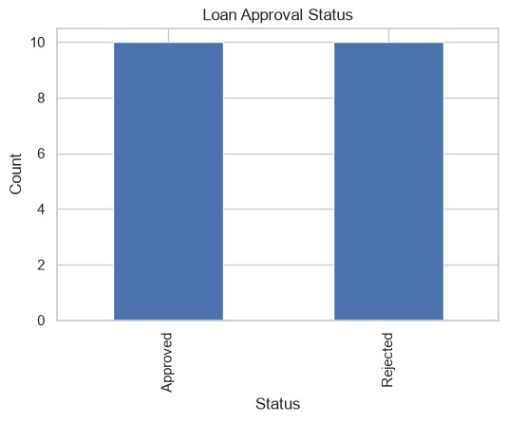
plt.figure(figsize=(6,4)) plt.hist(df4["Income"], bins=6, edgecolor="black") plt.title("Income Distribution") plt.xlabel("Income") plt.ylabel("Frequency") plt.show()
In [9]:
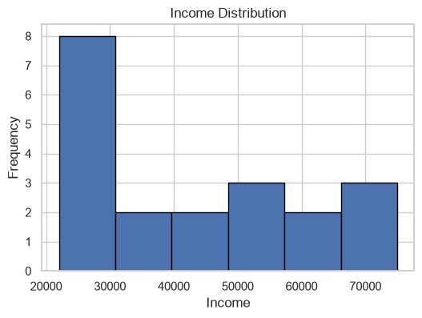
plt.figure(figsize=(6,4)) plt.scatter(df4["Credit_Score"], df4["Loan_Amount"]) plt.title("Credit Score vs Loan Amount") plt.xlabel("Credit Score") plt.ylabel("Loan Amount") plt.show()
In [10]:
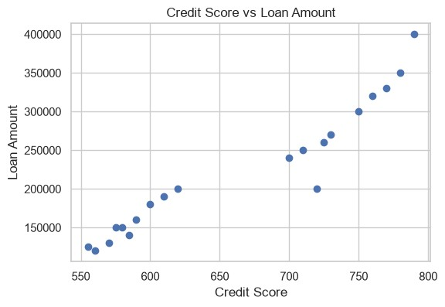
plt.figure(figsize=(6,4)) plt.boxplot(df4["Credit_Score"]) plt.title("Credit Score Box Plot") plt.show()
In [11]:
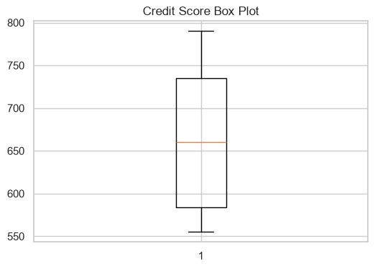
plt.figure(figsize=(5,5)) df4["Employment_Type"].value_counts().plot(kind="pie", autopct="%1.1f%%") plt.title("Employment Type Distribution") plt.ylabel("") plt.show()
In [12]:
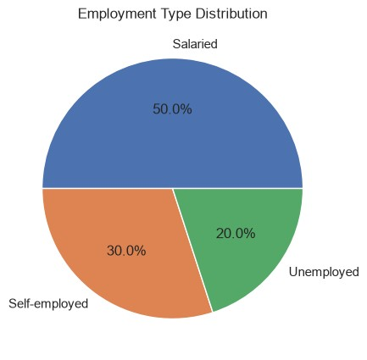
plt.figure(figsize=(6,4)) sns.heatmap(df4.select_dtypes(include=np.number).corr(), annot=True, cmap="coolwarm") plt.title("Correlation Heatmap") plt.show()
In [13]:
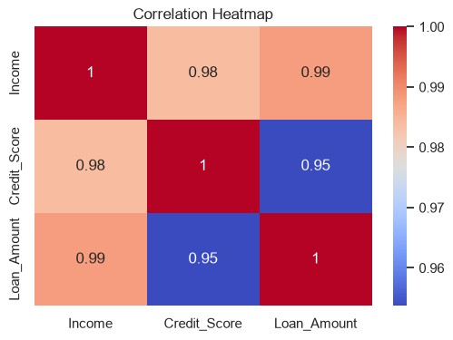
- Customers with higher credit scores are generally approved for larger loans.
- Salaried customers have a higher approval rate in this dataset.
- No missing values or duplicate records were found.
- Income and loan amount show a positive relationship.
- Credit score is an important factor in loan approval.
Conclusion

The Exploratory Data Analysis (EDA) indicates that **income, credit score, loan amount, and employment type** are important factors influencing loan approval decisions. Applicants with higher income and better credit scores are generally more likely to have their loans approved, while employment type also affects the approval process. The analysis provides valuable insights into customer financial profiles and lending patterns. These findings can help banks and financial institutions improve their loan evaluation process, minimize financial risk, reduce the chances of loan defaults, and make more accurate and fair lending decisions.

